TIMES OF INDIA (BANGALORE MIRROR) NEWS PAPER Dated: October 13, 2012
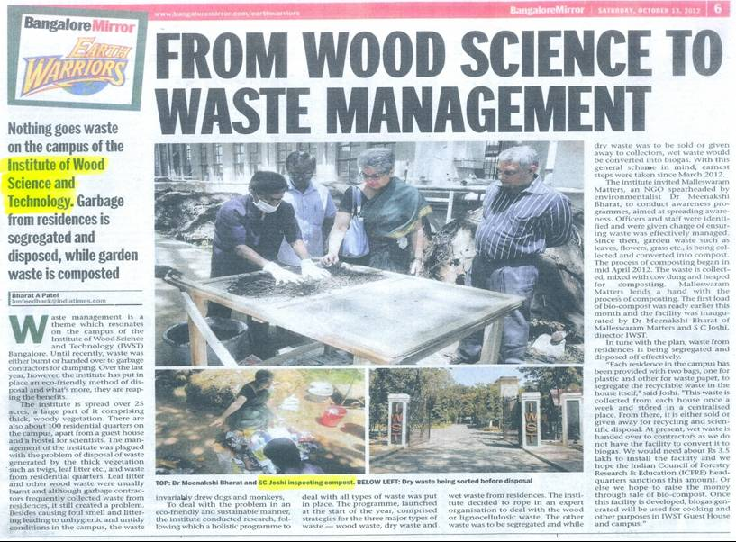
CITY PLUS (JAGRAN) BANGALORE NEWS PAPER Dated: October 6, 2012
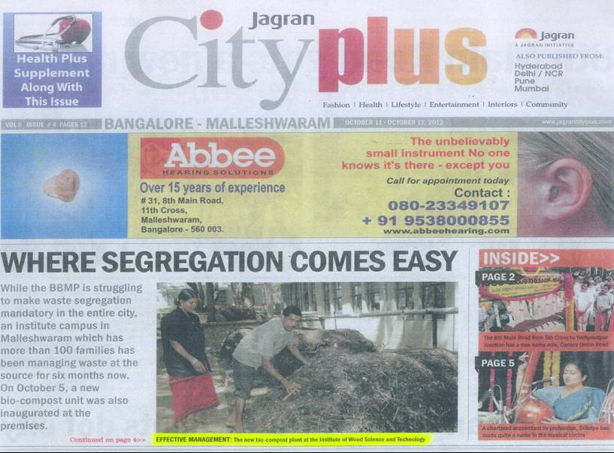
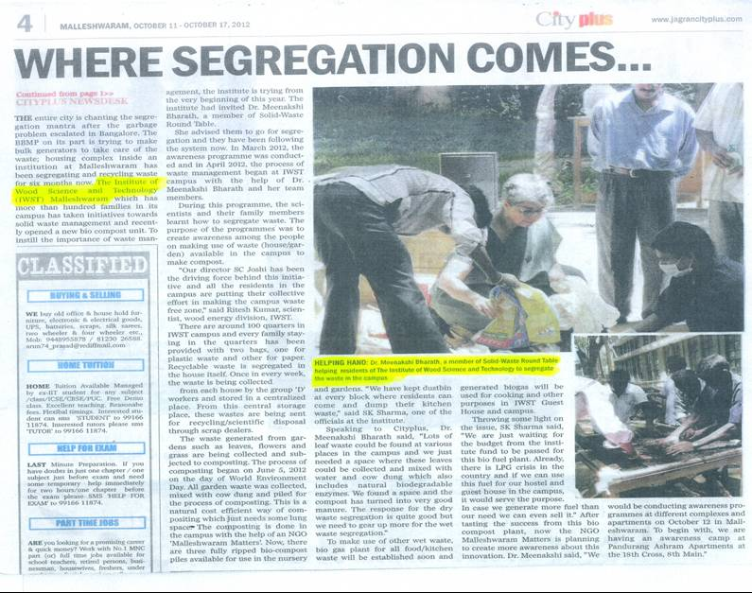
RAJASTHAN PATRIKA (BANGALORE) NEWS PAPER Dated: October 6, 2012

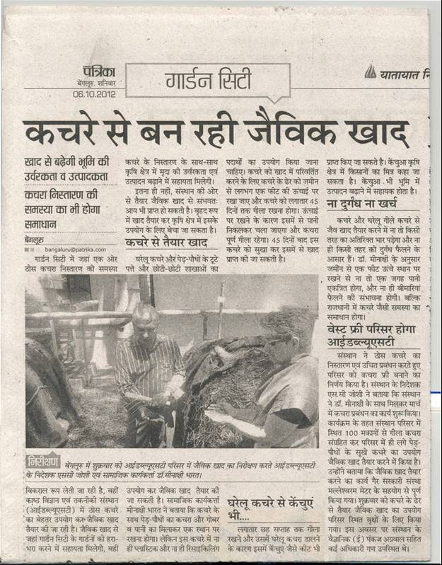
PRAJA VANI (BANGALORE) NEWS PAPER
Dated: October 6, 2012

